APES STUDY GUIDE: CHAPTER 24, pages 550-560
Please print this page and answer the questions in the space provided. All responses MUST BE HANDWRITTEN legibly. DO NOT SKIP THE CRITICAL THINKING QUESTIONS! They are old frq questions and will give valuable practice.

- What percentage of air is Oxygen gas, O₂? What percentage of air is Ozone (use the chart in Fig. 24.21)?

- Describe the characteristics of ozone, O₃. How is ozone produced?

- In what layer of the atmosphere is most of the ozone located? Why is this layer known as the ozone shield?

- Figure 24.21 shows 3 of the 4 layers of the atmosphere. You MUST learn these in order. Here is a mnemonic to help you or you can make up your own. WRITE YOUR OWN MNEMONIC HERE:
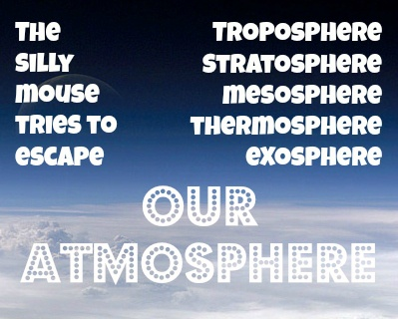

- Use figure 24.22 to compare and contrast the three types of UV light coming from the Sun. Which of these is known as the “ozone problem”?

- The absorption of ultraviolet radiation, UVC, by stratospheric ozone molecules causes ozone to photodissociate (decompose) and re-form. Describe the chemical processes that lead to the natural balance between photodissociation and formation of stratospheric ozone. THIS OZONE is known as the GOOD OZONE. You may include chemical equations in your answer.

- Think: how is this similar to or different than the formation of tropospheric (ground level) ozone?

- In what unit is ozone concentration reported?
- Over which continent is the ozone shield thinning- the proverbial ozone hole?

- During which season is the ozone shield the thinnest there?

- Think: ozone in the troposphere is a secondary pollutant formed from the photodissociation of NO_{x}. In this layer of the atmosphere, too much ozone is the real issue. This ozone is known as the BAD OZONE. Identify a human activity that leads to the formation of tropospheric ozone and explain why tropospheric ozone levels peak in the daytime.

- In 1974, Sherwood Rowland and Mario Molina predicted a thinning of the stratospheric ozone layer over Antarctica. Identify the class of chemical compounds that is primarily responsible for the thinning of the stratospheric ozone layer and list TWO major uses for this chemical.

- What is the residence time for CFCs? How can this explain why the ozone hole continues to exist even though CFCs were banned in the late 1980s?

- Which part of the CFC molecule is responsible for the depletion of stratospheric ozone?
- What is the immediate consequence of the depletion of stratospheric ozone by CFCs?

- Fully describe the process by which the CFCs destroy stratospheric ozone molecules. Please include chemical equations as part of your answer.

- What is the significance of polar stratospheric clouds in the depletion of stratospheric ozone?

- Ironically, the text discusses a benefit of NO_{X} in the stratosphere! What is that benefit?

- Why does ozone depletion occur more in the Antarctic EARLY spring? Why does this depletion slow down in LATE spring/early summer?

- Identify the major environmental consequence of depletion of stratospheric (good) ozone and describe ONE effect on ecosystems that can result.

- Describe TWO HEALTH IMPACTS of exposure to UVB radiation and describe TWO ways in which individuals can limit their exposure.

- The Montreal Protocol of 1987 provided a global framework to phase out chlorofluorocarbon (CFC) production and use. THIS IS THE MOST SUCCESSFUL INTERNATIONAL ENVIRONMENTAL TREATY! Although the Montreal Protocol has led to a dramatic decrease in CFCs released into the atmosphere, stratospheric ozone destruction has decreased only slightly. Explain why.

- What alternatives exist for CFC use? What are the advantages and disadvantages of these?

